[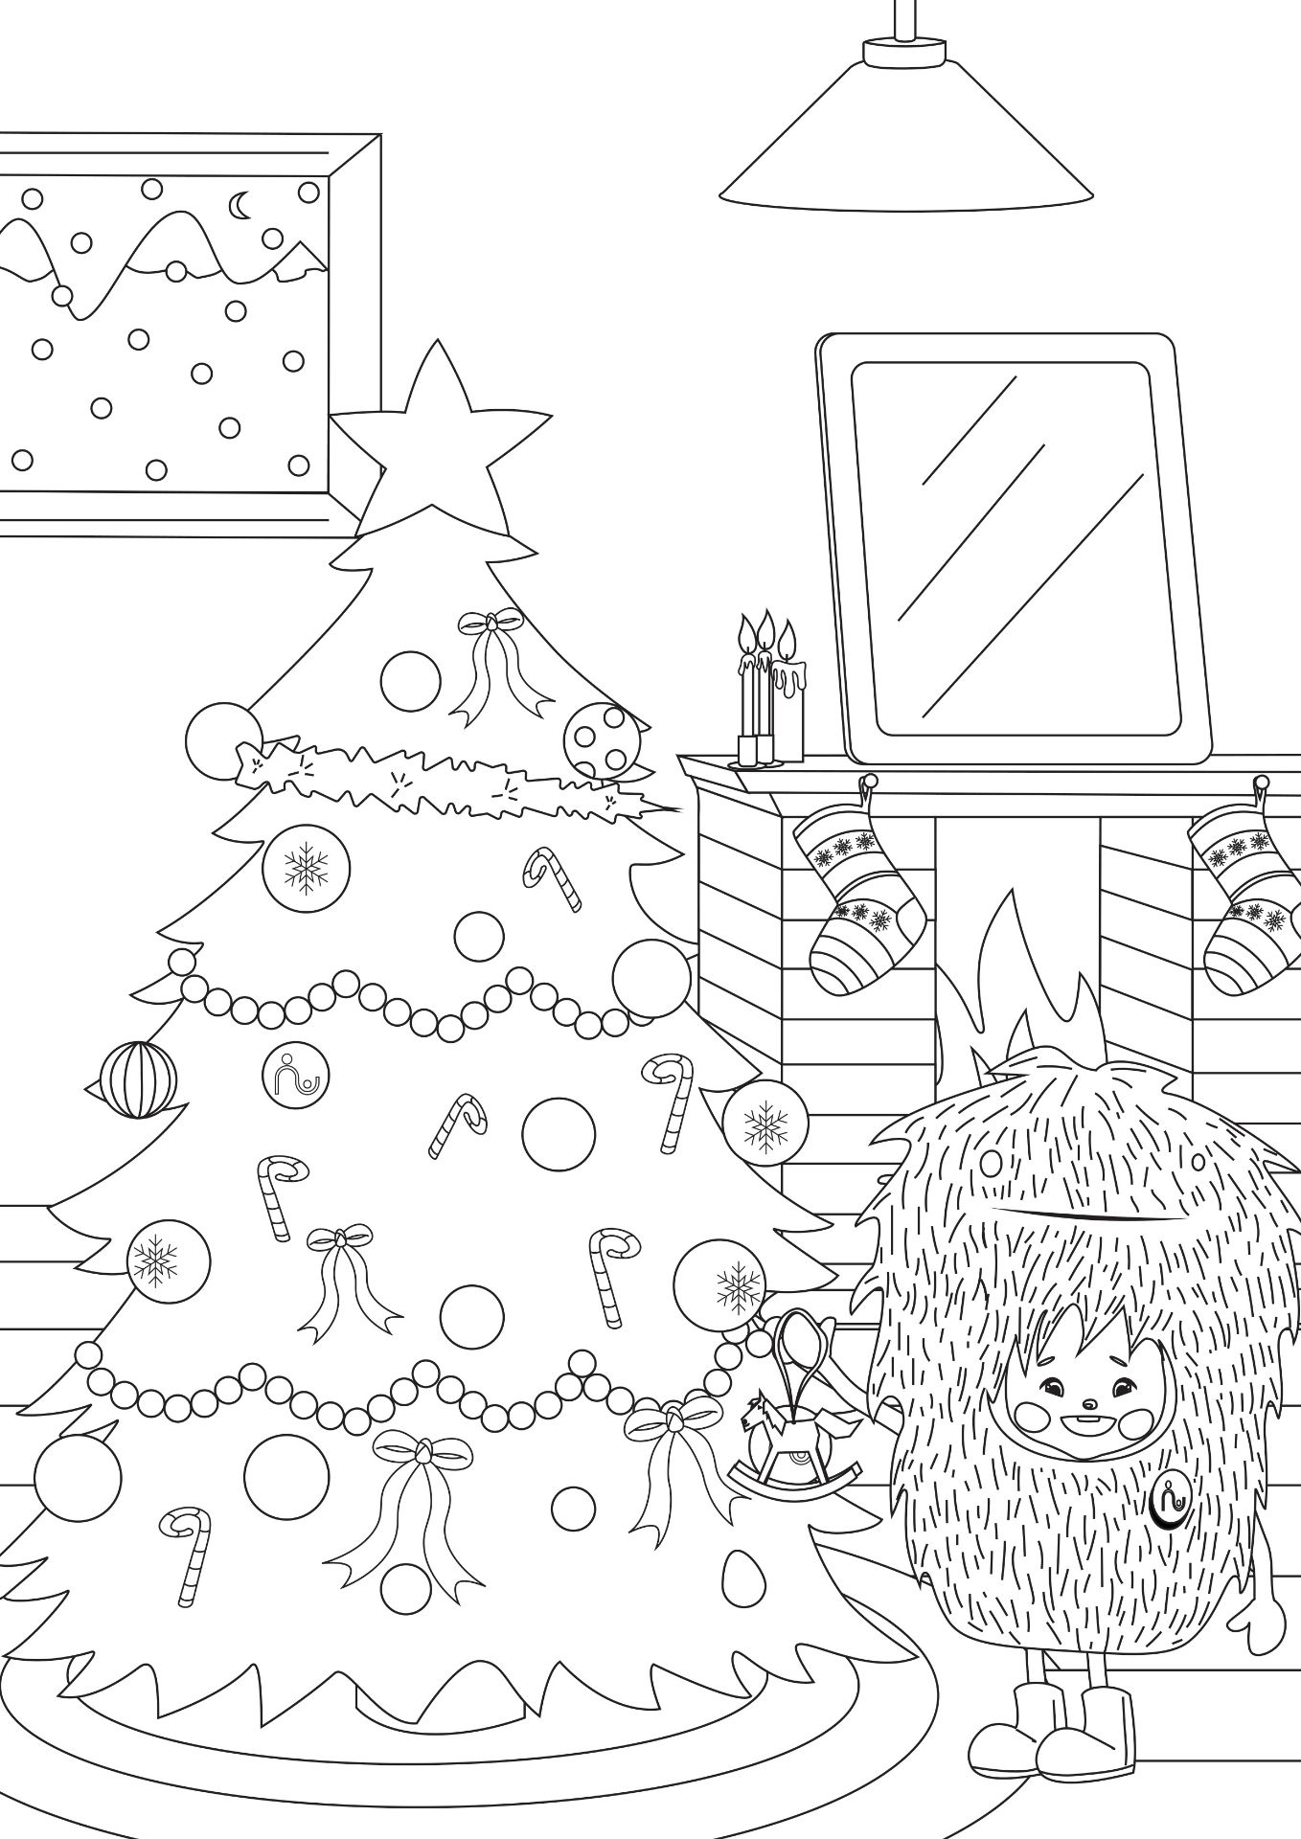](https://cdn.babysits.com/content/community/community-resources/en/christmas2020/christmas-tree-coloring-pages.pdf)